PERSONAL DETAILS | Dipeea Lahiri
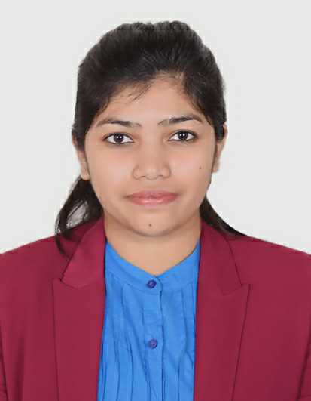 | Eden Garden Co-operative Housing Society,Viman Nagar,Pune,411014
 | +91 - 8879560990
 | dipeealahiri@gmail.com
 | https://www.linkedin.com/in/dipeea-lahiri-81a708111?
 |  dipeealahiri
 | Gender: W | Date Of Birth: 07/08/1992| Nationality: Indian
Looking for a challenging role in IT to enhance my skill set.

WORK EXPERIENCE
From (08/2019 - Present)  From (03/2017 - 08/2019)  From (09/2015 - 03/2017) | Application Development Senior Analyst at Accenture India Private Limited.
 | Software Engineer at Tech Mahindra Limited.
 | Assistant Systems Engineer at Tata Consultancy Services Limited.
EDUCATION

From (2011 - 2015)  From(2009 – 2011)  From(2007 – 2009) | B.TECH in Computer Science and Engineering from Meghnad Saha Institute of Technology,Kolkata with 8.24 C.G.P.A.
From (2011 - 2015)  From(2009 – 2011)  From(2007 – 2009) | Higher Secondary(XIIth) from St. Joseph’s High School,Matigara with 88.25% in Indian School Certificate Examination.
From (2011 - 2015)  From(2009 – 2011)  From(2007 – 2009) | Secondary(Xth) from St.Joseph’s High School,Matigara with 88% in Indian Certificate Of Secondary  Education Examination.

PROFESSIONAL SKILLS
- Worked as a Siebel CRM Developer for over 4.6 years in IT industry.
- Experienced in Siebel CRM and trained in Salesforce CRM.
- Worked in 3 Siebel Projects till date
- Familiar with applications like, Siebel Power Communications,Siebel Financial Services and Siebel Call Center
- Extensively skilled in Siebel Configuration(Applets,Business Components,Links,Joins,Views,Screens,Web Templates,Bitmaps,RTE,DVM,Symbolic String,User Properties).
- Worked in Siebel Scripting(Server scripting and browser scripting) and aware of Siebel Scripting Practices.Created custom Business Services(Server and Client) to achieve Client requirements.Used system functions to invoke command line via Siebel escript.Used Date functions to format date.
- Used Workflows and called Workflows via different methods like scripting,user properties,RTE,RCR,etc.
- Worked in Siebel EAI to integrate with external applications using middle ware such as EAI and OSB.Have experience in achieving integration services via SOAP webservices and JMS Queues.
- Familiar with Basics of Server Administration(server restart and component restart,increasing monitoring levels,commands,troubleshooting memory and space issues).
PROJECTS | - Currently working in Vodafone UK for Siebel Enhanements.  - Worked for Telecom Giant Vodafone India and activately participated in Merger of Vodafone and Idea and the transformation of this project from Oracle CRM to Siebel CRM.  - Worked for Client New India Assurance.

TOOLS USED | - Siebel Tools  - Salesforce  - SQL Developer  - WinSCP  - Putty  - SOAP UI  - HP ALM  - Workbench  - Siebel Web Client

HOBBIES | - Singing(Certified Classified Singer from Allahabad Singing Board and Bangiya Classical Parishad)  - Writing

LANGUAGES KNOWN | - English(Read,Write,Speak)  - Hindi(Read,Write,Speak)  - Bengali(Read,Write,Speak)  - German

FAMILY | - Father  - Mother  - Elder Brother

